DemoSat V final report

DemoSat V – The Mousetrap
Record orientation and vibration information during flight. Verify GPS position accuracy during flight ascent and descent. Develop a novel method for landing upright.

Students:

Matt Hoffman – Team captain, LandSat construction

Devlin Thyne – FieldSat/GPSSat construction, testing

David Fifield – FieldSat captain, all programming and code

Evan Spitler – Aid in LandSat construction, FieldSat testing, construction

Jason Igo – Support and testing

Faculty advisor

Keith Norwood

Metropolitan State College of Denver
Colorado Space Grant Consortium
October 1, 2007

Launch Date: 04 August 2007

Mission Statement:
Our team selected the following three missions for this flight: FieldSat, GPSSat, and LandSat. FieldSat was to gather and record three-dimensional attitude and acceleration data using three accelerometers and three gyroscopes with each set in 90°-offset spatial patterns. The purpose of GPSSat was to gather and record absolute four-dimensional positional data via GPS receiver. The LandSat was designed to use acceleration data at the end of the flight to determine stability of placement and orientation relative to gravity to determine an upright position, deploy, and photograph the environment to demonstrate a correct post-landing orientation. The team expected that by combining the relative orientation of FieldSat and the absolute position of GPSSat that some correlation can be derived between location and attitudinal activity.

Mission Requirements and Description:
The mission profile begins with the preflight activation, synchronization, and closure of the payload. While in flight, the payload is to remain closed and gather and record data from the three-axis accelerometers, the three-axis gyroscopes, and the GPS receiver. The program is designed to run in this configuration for three hours. After the three-hour program has run, the payload begins polling acceleration data to determine stability of orientation. Once the orientation data gives a stationary reading, the payload opens and begins to photograph the environment.

The major considerations for a mission of this type are lack of air, extreme cold (in comparison with temperatures normally found at the surface), and constant violent acceleration, particularly at balloon burst. The lack of air rules out a normally aspirating system, which is a minor concern in an electronic payload. This environmental consideration does require provision when combating the low temperatures of high altitude flight. The payload must be heated to ensure continuous operation during the mission. Additionally, the heating system must also be anaerobic. For this reason, we selected a resistive heating element and made consideration for the additional power load that such a system consumes. Passive insulation was also added to increase the effectiveness of the heating system. Due to the violent nature of the flight, structural considerations must be made to allow the payload to survive the mission. To accomplish structural soundness, the team selected a composite of foam core reinforced with a fiberglass wrap. This construction afforded both structural stability and a small degree of thermal insulation. The end result was a very robust outer hull.

Background: DemoSat IV
For DemoSat IV in 2006 we built a combination of FieldSat and SolarSat. The FieldSat mission was successful, recording the inertial data we anticipated. The recording did not last the entire flight and one of the sensors malfunctions partway through. The SolarSat mission was likewise successful. The solar panels deployed correctly and we measured varying output from them. The microcontroller and inertial measurement unit we developed became the basis for the FieldSat and GPSSat components of our DemoSat V mission.

Payload Design

Overview
The operation of the entire system is controlled by a central microcontroller and circuit board. The microcontroller reads measurements from the various sensors and writes them to a memory card. The controls the servo that deploys the package. It sends signals to the attached camera that instruct it when to take pictures.
We reused the firmware code that we developed for last year's mission. It is written in C using the AVR-Libc C library.The firmware's new responsibilities required a fair amount of new code. The code base grew from 1,100 line to about 1,500 lines.

Electrical Payload Design
The electrical payload was built-up from an Olimex development board for the ATmega series of microcontrollers. This board was chosen for its large prototyping area. Components placed on the board were connected using point-to-point soldering. This method of soldering made it easier to change the connections to components while being strong enough for flight. An Atmel ATmega32 microcontroller was selected for its eight channels of ten-bit analog to digital conversion, 32KByte of program space, UART port and SPI port. Three analog channels were used to measure three axes of accelerometer data. Another three analog channels were used to measure three axes of gyroscopic data. Two analog channels were left unused. The UART port was used to interface and receive data from a GPS receiver. The SPI port was used to send measured data to a MicroSD card

FieldSat Design
The FieldSat is basically an inertial measurement unit attached to a storage device. The inertial measurement unit consists of three accelerometers and three angular rate sensors (gyroscopes). The sensors are just integrated circuit chips and so are very small and light. We used the ADXRS300 angular rate sensor and ADXL321 linear accelerometer from Analog Devices. These are rated to have a range of ±300° / s and ±18 g, respectively. They each output an analog signal that is proportional to their measured quantity. The analog signal is converted to digital by the microcontroller and recorded.

GPSSat Design
The GPS component of the mission is provided by an attached EM-406A GPS receiver. This is connected to the microcontroller over a serial channel. The microcontroller only records the raw NMEA sentences provided by the receiver; it does not interpret them.

LandSat Design
The initial LandSat design was four equilateral triangular panels, measuring six inches on a side. These panels are connected with hinges, that, when closed, would form a tetrahedron and enclose the interior. This design was chosen because regardless of the final landing position the payload would right itself upon opening.
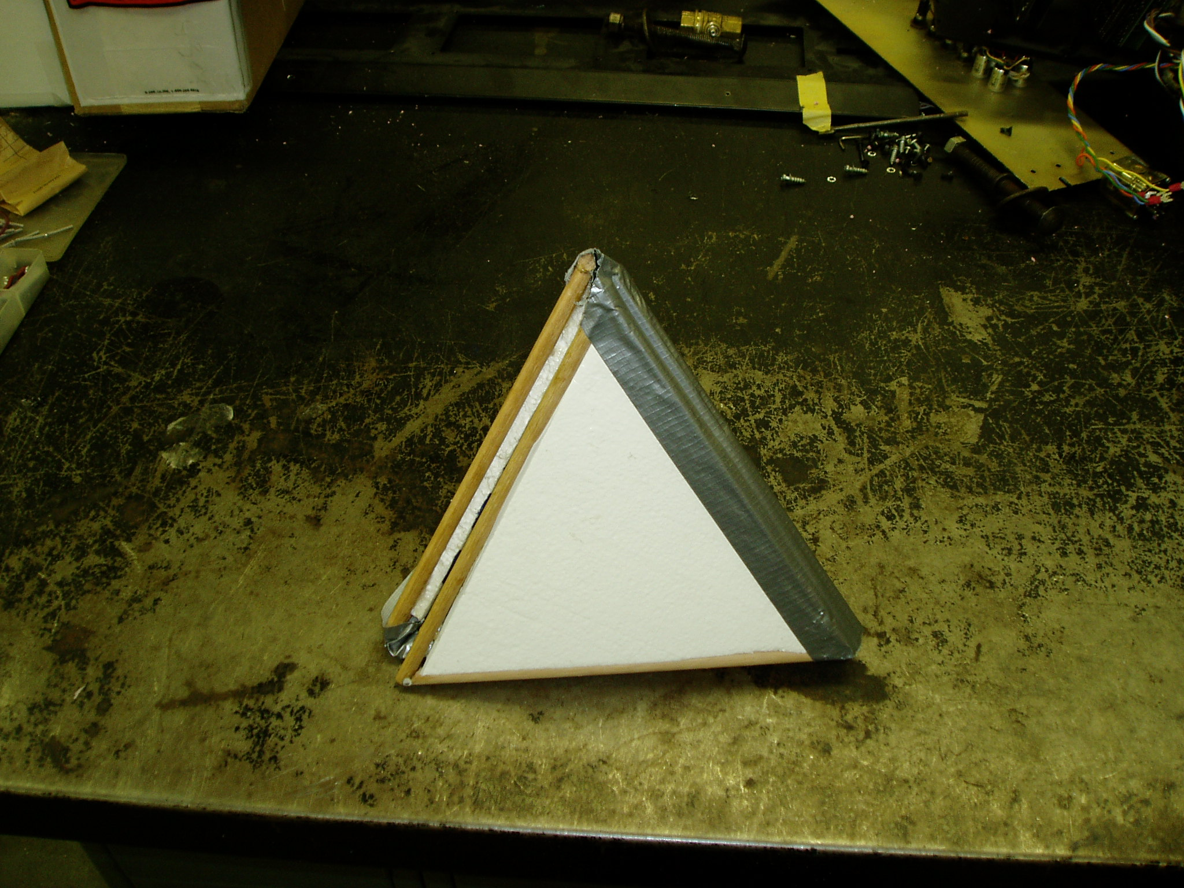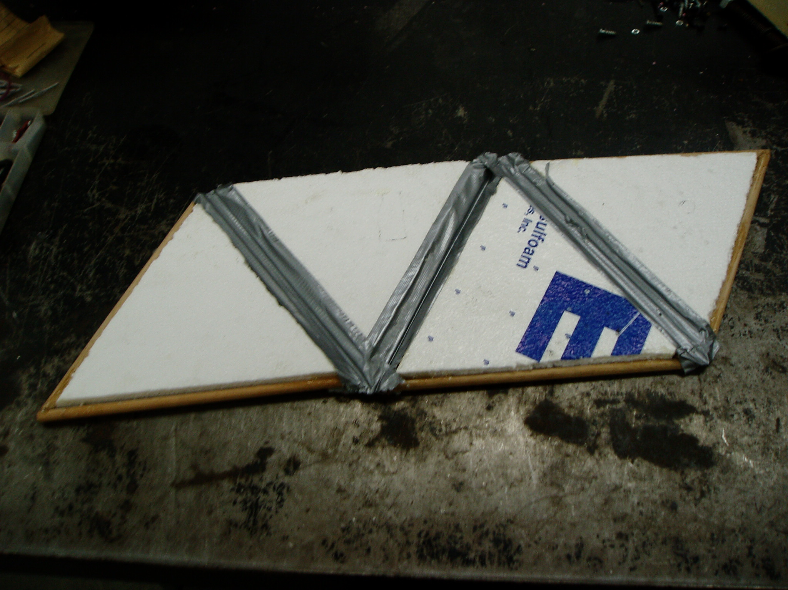
The initial design called for electronic linear actuators, controlled by the electronics package to be placed at each joint to open the payload. Upon completing further research, it was discovered that electronic linear actuators that were both strong and light enough for our application were unavailable. Due to this lack of availability, we decided to use pneumatic cylinders to open the payload.
The pneumatic cylinders required a tank to hold compressed air, along with a spool valve to control air supply to the cylinders. The pneumatic cylinders, the control valve, air tank, and lines/fittings were all commercially available in a kit designed to actuate landing gear on large remote control model aircraft.
The initial panel design was to construct a skeleton out of 3/8-inch diameter by 0.100-inch wall thickness pre-formed graphite tube around a 3/4-inch-thick high-density foam core. This skeleton/core panel would then be covered with epoxy-glass and then vacuum bagged. The hinges would be commercially available, manufactured for remote controlled aircraft kits.
It was decided at this time to increase the panel size to ten inches on a side prior to the first attempt at payload production. This increase in size would provide a greater internal volume to better accommodate the electronics package and deployment hardware.
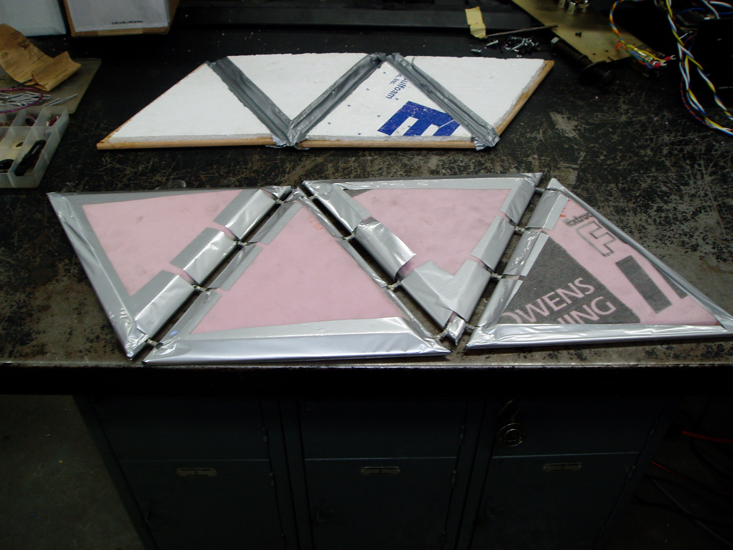
Upon completion of the first attempt of the payload, we discovered that the preformed graphite tube had problems bonding to the epoxy-glass and the hinges. The first payload design was extremely light weighing in at approximately 470 grams for all of the assembled hinged panels. For these reasons we decided to construct a third design for the final payload.
Prior to construction of the final payload, we consulted a composites expert. We found that strength could be increased drastically by:
  - Thickening the foam core. A doubling of the thickness would increase the strength of the panel by a factor of seven, while increasing weight by a factor of two.
  - Carbon fiber hinge reinforcement could be formed in place during construction using uncured carbon fiber cloth that would cure along with the epoxy-glass.
  - Using a heavier weight glass cloth. The outer sides of the panels were covered with a 9.8-ounce cloth while the interior sides of the panels were covered with the 3.2-ounce glass cloth used in the previous payload design.
The size of the final payload design was also increased by 50% to fifteen inches per side in order further maximize internal space. The increase in thickness allowed for panels to have recesses cast into them to provide integrated component mounting locations.

Expected data
The raw data recorded by the microcontroller consists of inertial measurements, GPS data, and other information such as the times at which pictures were taken. This is an example of the data format:
# Metro State Field/GPSSat data file format 2
# http://www.bamsoftware.com/wiki/DemoSatV/
TS=0355F20A DEPLOY=CLOSED NUMPHOTOS=0000
TS=03560D2B RX=01FA RY=01EE RZ=0203 AX=01FB AY=0207 AZ=01F8
TS=0356F7E6 GPS=$GPGSA,A,1,,,,,,,,,,,,,,,*1E
TS=03570EB1 RX=01FA RY=01EE RZ=0203 AX=01FB AY=0207 AZ=01F8
TS=0357E0FD GPS=$GPRMC,131431.325,V,,,,,,,040807,,*25
TS=0357F7E3 RX=01FB RY=01EE RZ=0203 AX=01FB AY=0207 AZ=01F8
TS=0358D12A GPS=$GPGGA,131432.325,,,,,0,00,,,M,0.0,M,,0000*54
. . .
TS=64B6AFB9 DEPLOY=OPEN NUMPHOTOS=0000
. . .
TS=68F7BFFE PHOTO=0001
There are samples for a timestamp (TS), which is just a 32-bit 8MHz counter; acceleration (AX, AY, and AZ) and rotation (RX, RY, and RZ); which are the raw digital values recorded from the sensors recorded in hexadecimal; GPS recordings (GPS), which are uninterpreted NMEA sentences; and other status information such as the number of pictures taken.
The inertial sensors are sampled about 65 times per second. The GPS data are recorded whenever they are provided by the GPS receiver, which is typically three or four times per second.

Student Involvement
David Fifield (computer science)
Programming of firmware and off-line analysis software.

Matt Hoffman (mechanical engineering technology)
Lander design and fabrication, testing.

Jason Igo (civil engineering technology)
Advising.

Evan Spitler (mechanical engineering technology)
Lander fabrication, testing.

Devlin Thyne (electrical engineering technology)
Electrical design and fabrication, testing.

Testing Results

Testing was preformed at several steps during construction, samples of potential construction materials were linear static stress tested using an Instron test machine. The finished payload was thoroughly abuse tested, and the gps was allowed to record data several times while in transit. More detailed information on testing can be found in the L.R.R. presentation.

Mission Results

Material Condition
Fortunately, the payload landed in a field very near to the road and we were able to be on scene within minutes of landing. Upon arrival, we found a deployed, upright payload with all components in their designated locations. There was some minor abrasion to the outside of the hull, but the payload was completely intact. Unfortunately, during the flight, shortly after the burst, the package lost power, resulting in no data being recorded after that point. A look at the battery output at time of recovery indicated that the battery was very near the end of its useful life.

Data Recovery
The memory card contained about 24 MB of raw data, spanning an interval of about 1:47:33 hours, from 7:14:31 AM until 9:02:04 AM. While we didn't record the entire flight, we got the entire ascent and about 22 minutes of the descent, missing about 16 minutes of the end of the flight.
It was disappointing to again fail to record the entire mission. This time, however, we recorded more of the mission overall, and didn't experience any of the sensor malfunctions that tainted our data the last time.

Inertial Measurements
We recorded inertial measurements during the entire flight. The measurements are approximate because the sensors were not precisely calibrated. Here is a tabulated summary.
Measurement | Minimum | Maximum | Mean | Standard deviation
Acceleration along X axis | −10.70 g | 1.30 g | −3.58 g | 1.32 g
Acceleration along Y axis | −18.14 g | 7.77 g | −0.99 g | 3.68 g
Acceleration along Z axis | −2.02 g | 13.60 g | 6.43 g | 2.62 g
Magnitude of acceleration | 4.22 g | 23.04 g | 8.76 g | 0.81 g
Rotation about X axis | −124.94° / s | 103.80° / s | −4.93° / s | 20.95° / s
Rotation about Y axis | −37.40° / s | 26.50° / s | 0.06° / s | 3.97° / s
Rotation about Z axis | −76.34° / s | 83.61° / s | 2.53° / s | 13.69° / s

GPS Measurements
We compiled our GPS measurements into a KML file so that they can be seen in geographic visualization programs. Pictures of the flight path are below.
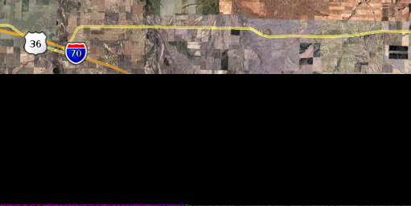
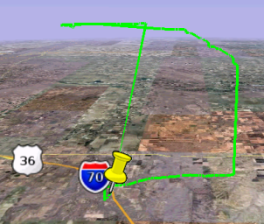
For some reason, GPS altitude readings were recorded only sporadically. There were two large gaps during which no measurements are recorded, which accounts for the jumps seen in the recorded flight path. This graph shows GPS altitude measurements over time:
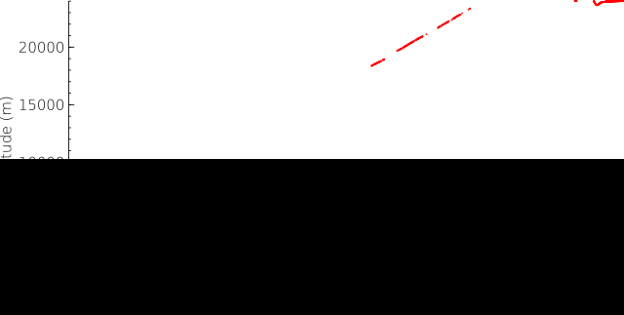

Visualization Video
We created a video showing the orientation and movement of the payload during the entire time it was active. Some still frames depicting the payload during launch are shown.

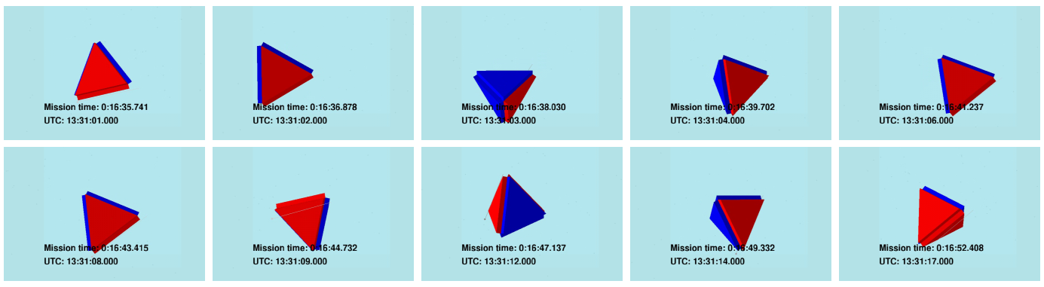
We hope to make the entire video available for download in a convenient format.
Unfortunately, because of our spotty GPS data and a lack of time, we did not integrate the orientation and acceleration information with the position information.
Just as with our in-flight firmware, source code for the visualization programs is available at the web site. A discussion of the methods used to create the visualization video is in the paper “Inertial measurement and realistic post-flight visualization,” Proc. of the Colorado Space Grant Consortium Undergraduate Symposium, 2007. This paper was a result of our DemoSat IV mission.

Payload Recovery
The payload opened a few minutes before landing; fortunately the pre-deployed payload landed in correct orientation. We attribute the premature deployment to the power loss that occurred shortly after burst. When the battery dropped below the minimum requirements for the circuit, the servo pulled intermittent power, causing a twitching movement in the horn that jostled the pneumatic valve enough to slowly bleed the pressure out of the cylinder. Upon inspection, we found the compressed air tank was completely discharged, providing little-to-no resistance in the cylinders against outside force.
Due to the power loss, the on-board camera was unable to photograph the environment after landing.

Conclusions
This year’s partial success showed marked improvement in data acquisition and overall payload design from last year’s design. The addition of two subsystems met with mixed results: the GPS unit was of great benefit to the data picture when it was receiving data. The deployment system was sound but could use some refinement. Finally, the payload package could be leaner without sacrificing too much structural integrity.

Web site
All our results and other information related to our DemoSat flight (including source code) are published on the web at http://www.bamsoftware.com/wiki/DemoSatV.

Potential Follow-on Work
The design of the payload can be improved in a few ways. The electronics package can be developed from the test board into a printed circuit board. The end result would be a smaller and lighter package that can be used in a variety of applications. A stronger battery can be used to ensure adequate power throughout the flight. Because of the strength of the composite used in the hull of the payload, less material is required in the construction at a minimal structural cost, resulting in reduced mass and less strain on the budget. The GPS system requires further refinement to achieve maximum data acquisition with a minimum gap in coverage.

Benefits to NASA and the Scientific Community
We have created a design for a low-cost yet effective inertial measurement unit.
Though it deployed prematurely, our LandSat shows that a terrestrial lander can be made with only three actuators.
The benefits provided by our mission include more than just our collected data. There is currently a lack of peer review and cooperation between DemoSat teams. By publishing our design and source code, we allow others to reproduce and extend our results. We hope to encourage cooperation between participants and thereby increase the quality of students available to join the scientific community.
Our inertial and GPS measurements may help to improve similar balloon-based experiments by giving participants realistic expectations for values such as maximum acceleration. Our visualization video gives viewers a sense of what it's “really like” during liftoff and burst.

Lessons Learned
We have gained some valuable insight into the production of integrated systems. Power consumption is one of the most critical considerations in self-controlled devices. A higher-capacity battery would have prevented the lapse in data coverage as well as the premature deployment of the landing system. However important power management can be, the ultimate importance in projects of this type lies in the group dynamic. In order to continue productivity, all members of the team need to put forth the effort to do so. Often a group can be held up by a single specialist. To combat delays when such a specialist is unavailable, the specialists form other disciplines should have enough knowledge to fill the gap.

